

**Department of Computer Science**

**Engineering (AI)**

**ARTIFICAL INTELLIGENCE**

**Project Report**

**On**

**Sales Data Analysis and Visualization**

**By**

ANUSHKA KAUSHAL

**Date**: 09/01/2025



1

**Sales Data Analysis and Visualization**  
**Project Report**

**1. Introduction**

In today’s competitive market, businesses need to analyze their sales data to make informed decisions. This project focuses on **Sales Data Analysis and Visualization** to identify trends, product performance, and revenue distribution using Python and data visualization libraries like **Matplotlib** and **Seaborn**.

**2. Objectives**

The key objectives of this project are:

* To analyze sales trends over time.
* To visualize product-wise sales distribution.
* To analyze revenue distribution across different products.
* To generate meaningful insights from the given dataset.

**3. Tools & Technologies Used**

* **Programming Language:** Python
* **Libraries:** Pandas, Matplotlib, Seaborn
* **Development Environment:** Google Colab / Jupyter Notebook
* **Dataset Format:** CSV (Comma-Separated Values)

**4. Dataset Description**

The dataset used in this project consists of sales-related data. The key columns in the dataset include:

| **Column Name** | **Description** |
| --- | --- |
| **Date** | The date on which the sale occurred. |
| **Product** | The name of the product sold (e.g., Phone, Laptop, Tablet). |
| **UnitsSold** | The number of units sold for the product. |
| **Revenue** | The total revenue generated from the product sales. |

**5. Implementation Steps**

**Step 1: Importing Libraries**

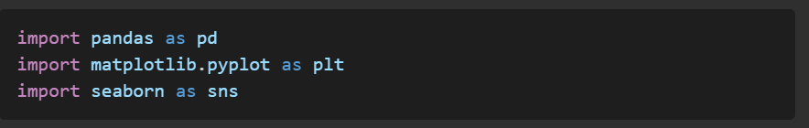

**Step 2: Loading and Preprocessing Data**

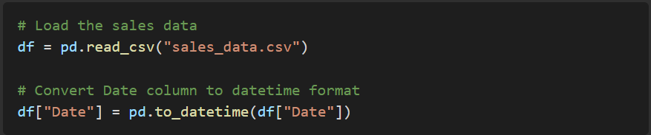

**Step 3: Sales Trend Over Time**

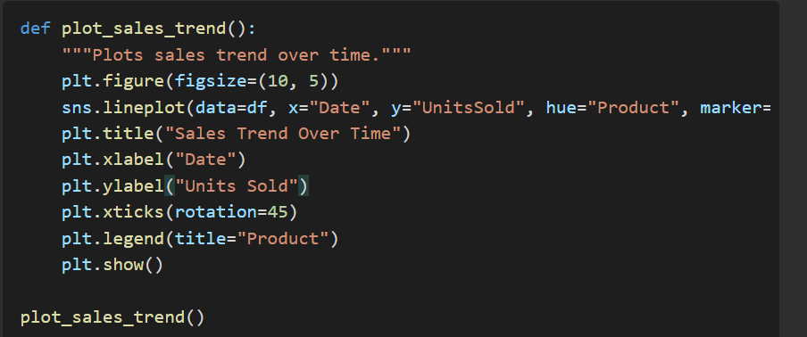

**Step 4: Total Units Sold per Product**

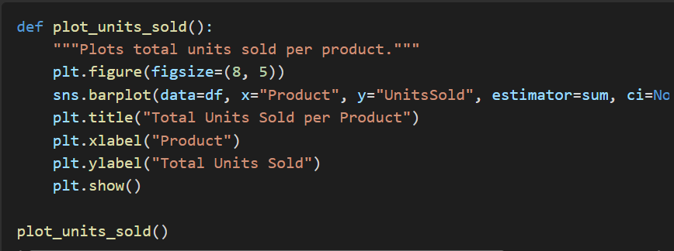

**Step 5: Revenue Distribution Among Products**

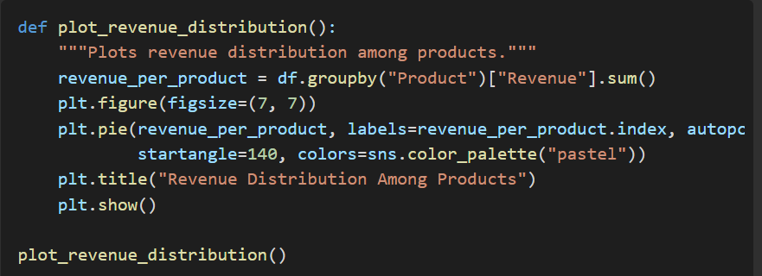

**6. Results & Analysis**

* The **Sales Trend Over Time** graph shows how product sales fluctuate over different dates.
* The **Total Units Sold per Product** bar chart helps identify which product has the highest and lowest sales.
* The **Revenue Distribution Pie Chart** provides insights into the revenue contribution of each product.

**7. Conclusion**

This project successfully demonstrates the power of **data visualization in sales analysis**. By leveraging Python’s **Pandas, Matplotlib, and Seaborn**, we were able to extract key insights from the dataset, which can help businesses improve decision-making processes. Future improvements could include **predictive analysis using Machine Learning** to forecast sales trends.

**8. Future Scope**

* Adding **interactive dashboards** using Plotly or Dash.
* Implementing **Machine Learning models** to predict future sales.
* Automating data updates for real-time analysis.

**Prepared by: ANUSHKA KAUSHAL**

**Date:** 11-03-2025